**Project Design Phase-II**

**Technology Stack (Architecture & Stack)**

|  |  |
| --- | --- |
| Date | 17th October 2022 |
| Team ID | PNT2022TMID00524 |
| Project Name | DemandEst – AI POWERED FOOD DEMAND FORECASTER |
| Maximum Marks | 4 Marks |

**Technical Architecture:**

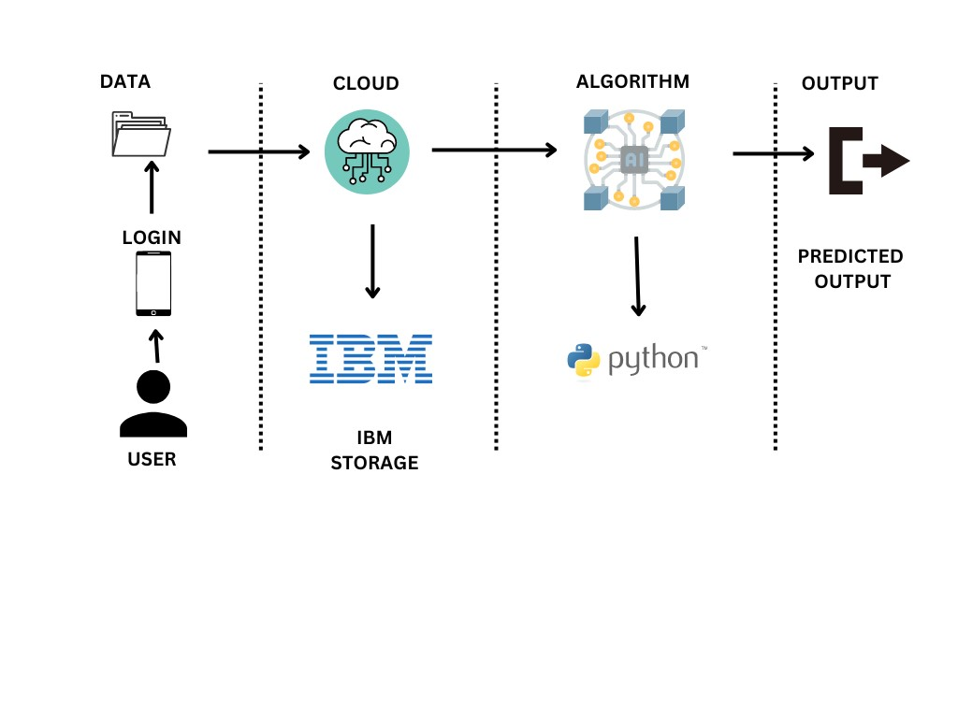

**Table-1 : Components & Technologies:**

|  |  |  |  |
| --- | --- | --- | --- |
| **S No** | **Component** | **Description** | **Technology** |
| 1. | User Interface | User access to the application through the mobile application. | HTML |
| 2. | Application Logic-1 | Creating an application interface | Python |
| 3. | Application Logic-2 | Creating an AI assistant that gives food services to the user. | IBM Watson Assistance |
| 6. | File Storage | Files are stored in the local storage and stored in the cloud. | IBM Block Storage or Other Storage  Service or Local File system |
| 7. | External API-1 | Use this REST API to manage locations. Get all locations. URI, /admin/resources/locations. | IBM Location REST API |
| 8. | Deep Learning Model | Creating an algorithm to calculate case information provides by the fulfillment center. | Object Recognition Model, etc. |
| 9. | Infrastructure (Cloud) | IBM Cloud App Configuration is a centralized feature-management and configuration service on IBM Cloud. | IBM Cloud Foundry |

**Table 2: Application Characteristics**:

|  |  |  |  |
| --- | --- | --- | --- |
| **S No** | **Characteristics** | **Description** | **Technology** |
| 1. | Open-Source Frameworks | There are no open-source frameworks in this application. | Python |
| 2. | Security Implementations | Block chain technology is used for Security implementation its private framework protects all data. | Block chain |
| 3. | Scalable Architecture | Users are provided with food services in online and they can also get info about the recent highly used products. In this model costumer gets benefits on analyzing their industry data and provides prediction on day to day analysis of food that sold and reduce the wastage of food by predicting its sales movements. | IBM Cloud |
| 4. | Availability | Here data are updated and the demands were predicted according to the data. | IBM Watson Assistant |
| 5. | Performance | The geo-fencing algorithm is updated daily and shows the day-to-day updates of the contaminated zones. | Geo fence |